**Kubernetes Deployment Options on AWS**

Amazon Web Services provides three main options for deploying Kubernetes:

1. Running Kubernetes directly on Amazon EC2 machines  
   2. Using the Amazon Elastic Kubernetes Service (EKS)

Amazon EKS (Elastic Container Service for Kubernetes) is a managed Kubernetes service that allows you to run Kubernetes on AWS without the hassle of managing the Kubernetes control plane.

The [Kubernetes control plane](https://kubernetes.io/docs/concepts/#kubernetes-control-plane) plays a crucial role in a Kubernetes deployment as it is responsible for how Kubernetes communicates with your cluster — starting and stopping new containers, scheduling containers, performing health checks, and many more management tasks.

The big benefit of EKS, and other similar hosted Kubernetes services, is taking away the operational burden involved in running this control plane. You deploy cluster worker nodes using defined AMIs and with the help of CloudFormation, and EKS will provision, scale and manage the Kubernetes control plane for you to ensure high availability, security and scalability.

Step 0: Before you start

You will need to make sure you have the following components installed and set up before you start with Amazon EKS:

* AWS CLI – while you can use the AWS Console to create a cluster in EKS, the AWS CLI is easier. You will need version 1.16.73 at least. For further instructions, click [here](https://docs.aws.amazon.com/cli/latest/userguide/cli-chap-install.html).
* Kubectl – used for communicating with the cluster API server. For further instructions on installing, click [here](https://docs.aws.amazon.com/eks/latest/userguide/install-kubectl.html). This endpoint is public by default, but is secured by proper configuration of a VPC (see below).
* AWS-IAM-Authenticator – to allow IAM authentication with the Kubernetes cluster. Check out the [repo on GitHub](https://github.com/kubernetes-sigs/aws-iam-authenticator) for instructions on setting this up.

Step 1: Creating an EKS role

Our first step is to set up a new IAM role with EKS permissions.

Open the [IAM console](https://console.aws.amazon.com/iam/), select **Roles** on the left and then click the **Create Role**button at the top of the page.

From the list of AWS services, select **EKS** and then **Next: Permissions**at the bottom of the page.

[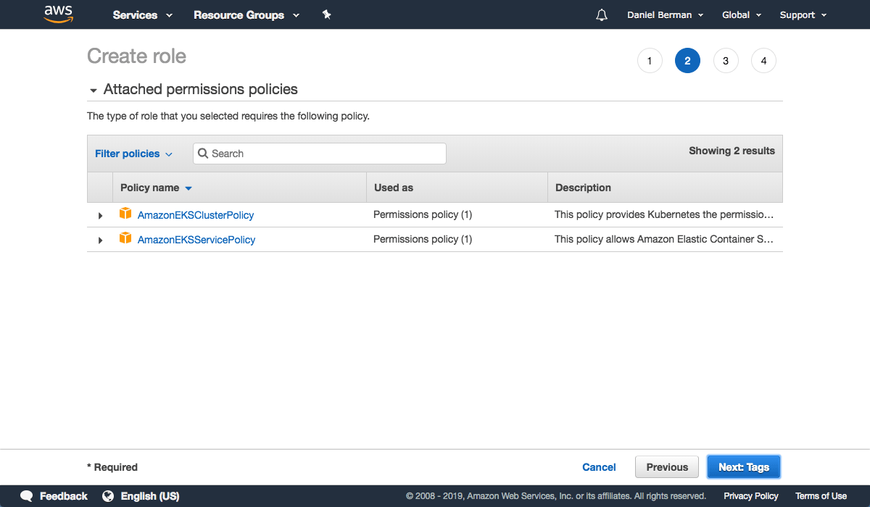](https://logz.io/wp-content/uploads/2019/02/createrole.png)

Leave the selected policies as-is, and proceed to the Review page.

[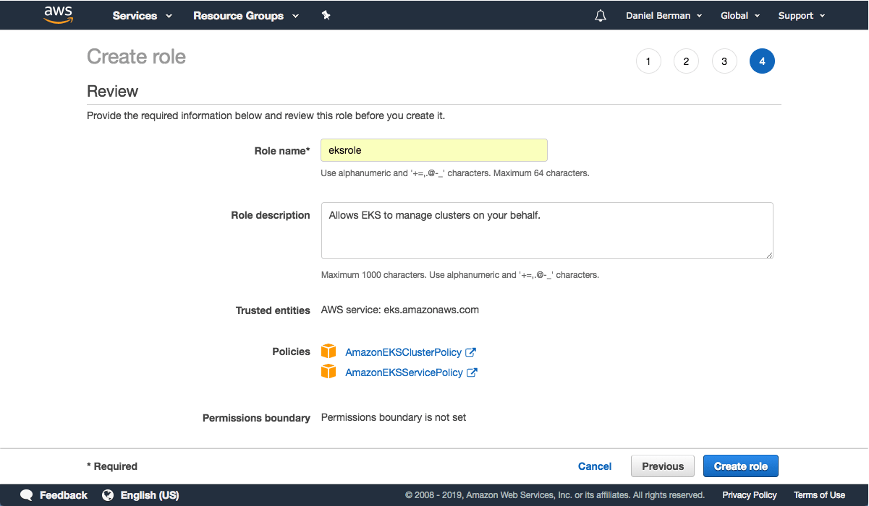](https://logz.io/wp-content/uploads/2019/02/role-review.png)

Enter a name for the role (e.g. *eksrole*) and hit the **Create role** button at the bottom of the page to create the IAM role.

The IAM role is created.

[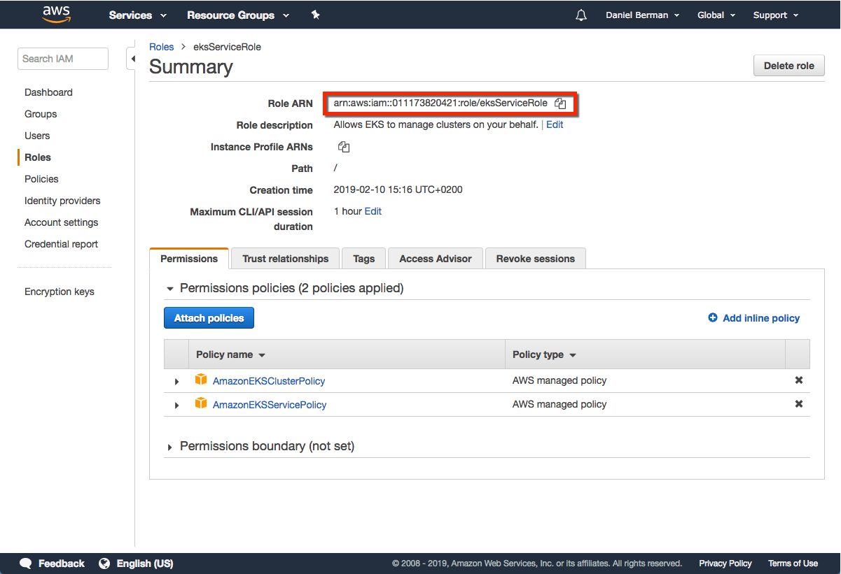](https://logz.io/wp-content/uploads/2019/02/Summary.png)

Be sure to note the Role ARN, you will need it when creating the Kubernetes cluster in the steps below.

Amazon EKS also offers [service account IAM roles](https://docs.aws.amazon.com/eks/latest/userguide/iam-roles-for-service-accounts.html), eliminating previous iterations’ requirement for extended worker node permissions.

Step 2: Creating a VPC for EKS

Next, we’re going to create a separate VPC—a Virtual Private Cloud that protects communication between worker nodes and the AWS Kubernetes API server— for our EKS cluster. To do this, we’re going to use a CloudFormation template that contains all the necessary EKS-specific ingredients for setting up the VPC.

Open up [CloudFormation](https://console.aws.amazon.com/cloudformation), and click the **Create new stack** button.

On the **Select template** page, enter the URL of the CloudFormation YAML in the relevant section:

https://amazon-eks.s3-us-west-2.amazonaws.com/cloudformation/2019-01-

09/amazon-eks-vpc-sample.yaml

Copy

[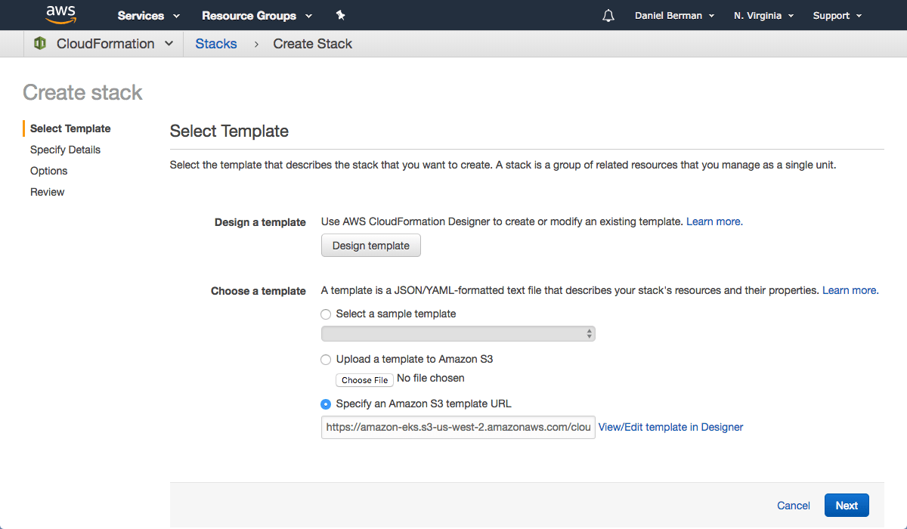](https://logz.io/wp-content/uploads/2019/02/create-stack.png)

Click **Next**.

[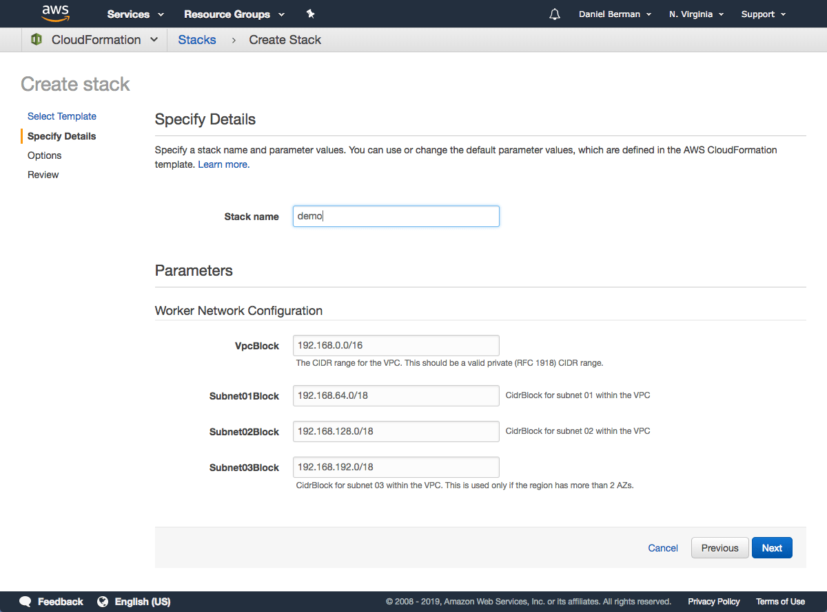](https://logz.io/wp-content/uploads/2019/02/specify-details.png)

Give the VPC a name, leave the default network configurations as-is, and click **Next**.

On the Options page, you can leave the default options untouched and then click **Next**.

[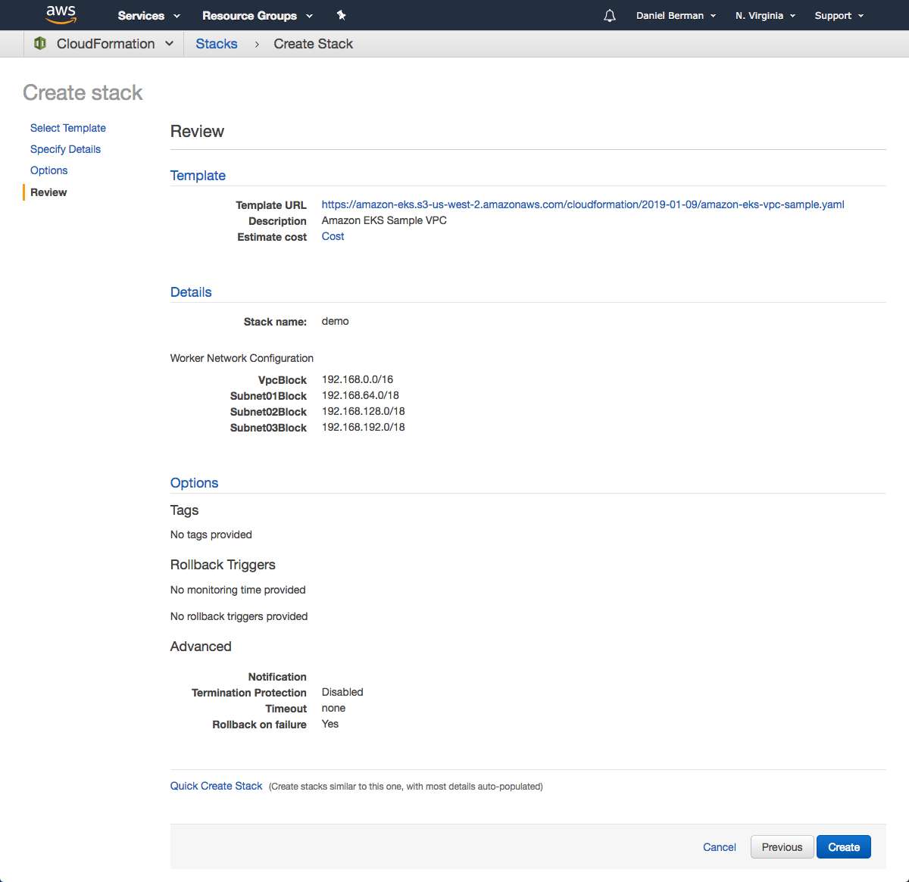](https://logz.io/wp-content/uploads/2019/02/create-vpc.png)

On the Review page, simply hit the **Create** button to create the VPC.

CloudFormation will begin to create the VPC. Once done, be sure to note the various values created — SecurityGroups, VpcId and SubnetIds. You will need these in subsequent steps. You can see these under the Outputs tab of the CloudFormation stack:

[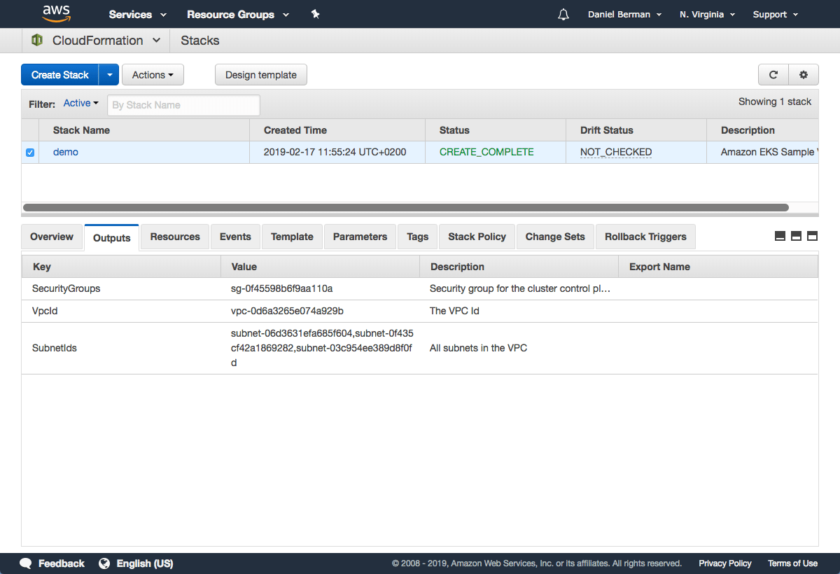](https://logz.io/wp-content/uploads/2019/02/demo.png)

As of December 2019, you can configure the [private](https://docs.aws.amazon.com/eks/latest/userguide/cluster-endpoint.html) access point of the API server from outside of the VPC.

Ensure you have set to *true* the *enableDnsHostnames* and *enableDnsSupport* fields, otherwise routing to the API server won’t work.

Step 3: Creating the EKS cluster

As mentioned above, we will use the AWS CLI to create the Kubernetes cluster. To do this, use the following command:

[](https://logz.io/wp-content/uploads/2019/02/demo-1.png)

aws eks --region <region> create-cluster --name <clusterName>

--role-arn <EKS-role-ARN> --resources-vpc-config

subnetIds=<subnet-id-1>,<subnet-id-2>,<subnet-id-3>,securityGroupIds=

<security-group-id>

Copy

**Be sure to replace the bracketed parameters as follows:**

* region — the region in which you wish to deploy the cluster.
* clusterName — a name for the EKS cluster you want to create.
* EKS-role-ARN — the ARN of the IAM role you created in the first step above.
* subnetIds — a comma-separated list of the SubnetIds values from the AWS CloudFormation output that you generated in the previous step.
* security-group-id — the SecurityGroups value from the AWS CloudFormation output that you generated in the previous step.

This is an example of what this command will look like:

aws eks --region us-east-1 create-cluster --name demo --role-arn

arn:aws:iam::011173820421:role/eksServiceRole --resources-vpc-config

subnetIds=subnet-06d3631efa685f604,subnet-0f435cf42a1869282,

subnet-03c954ee389d8f0fd,securityGroupIds=sg-0f45598b6f9aa110a

Copy

Executing this command, you should see the following output in your terminal:

{

"cluster": {

"status": "CREATING",

"name": "demo",

"certificateAuthority": {},

"roleArn": "arn:aws:iam::011173820421:role/eksServiceRole",

"resourcesVpcConfig": {

"subnetIds": [

"subnet-06d3631efa685f604",

"subnet-0f435cf42a1869282",

"subnet-03c954ee389d8f0fd"

],

"vpcId": "vpc-0d6a3265e074a929b",

"securityGroupIds": [

"sg-0f45598b6f9aa110a"

]

},

"version": "1.11",

"arn": "arn:aws:eks:us-east-1:011173820421:cluster/demo",

"platformVersion": "eks.1",

"createdAt": 1550401288.382

}

}

Copy

It takes about 5 minutes before your cluster is created. You can ping the status of the command using this CLI command:

aws eks --region us-east-1 describe-cluster --name demo --query

cluster.status

Copy

The output displayed will be:

"CREATING"

Copy

Or you can open the Clusters page in the [EKS Console](https://console.aws.amazon.com/eks/):

[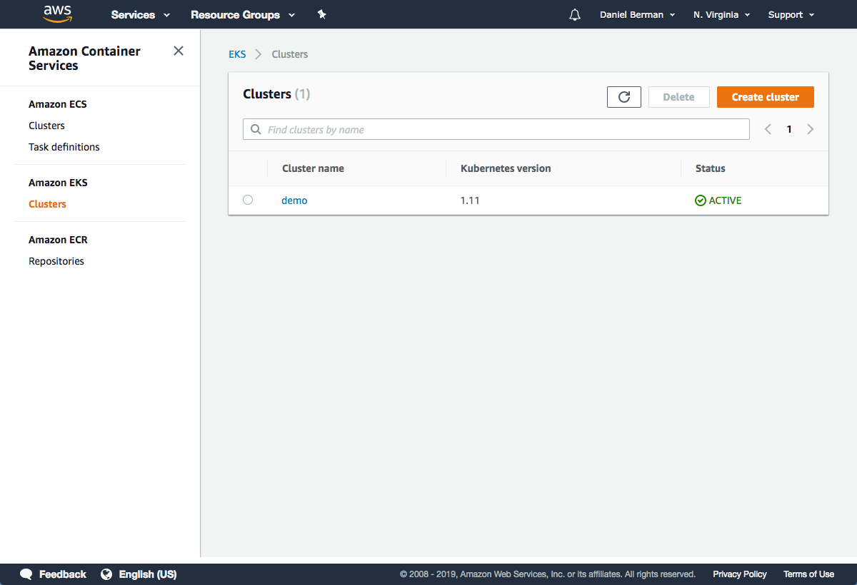](https://logz.io/wp-content/uploads/2019/02/clusters.png)

Once the status changes to “ACTIVE”, we can proceed with updating our kubeconfig file with the information on the new cluster so *kubectl* can communicate with it.

To do this, we will use the AWS CLI update-kubeconfig command (be sure to replace the region and cluster name to fit your configurations):

aws eks --region us-east-1 update-kubeconfig --name demo

Copy

You should see the following output:

Added new context arn:aws:eks:us-east-1:011173820421:cluster/demo to

/Users/Daniel/.kube/config

Copy

We can now test our configurations using the kubectl get svc command:

kubectl get svc

NAME TYPE CLUSTER-IP EXTERNAL-IP PORT(S) AGE

kubernetes ClusterIP 10.100.0.1 <none> 443/TCP 2m

Copy

Click the cluster in the EKS Console to review configurations:

[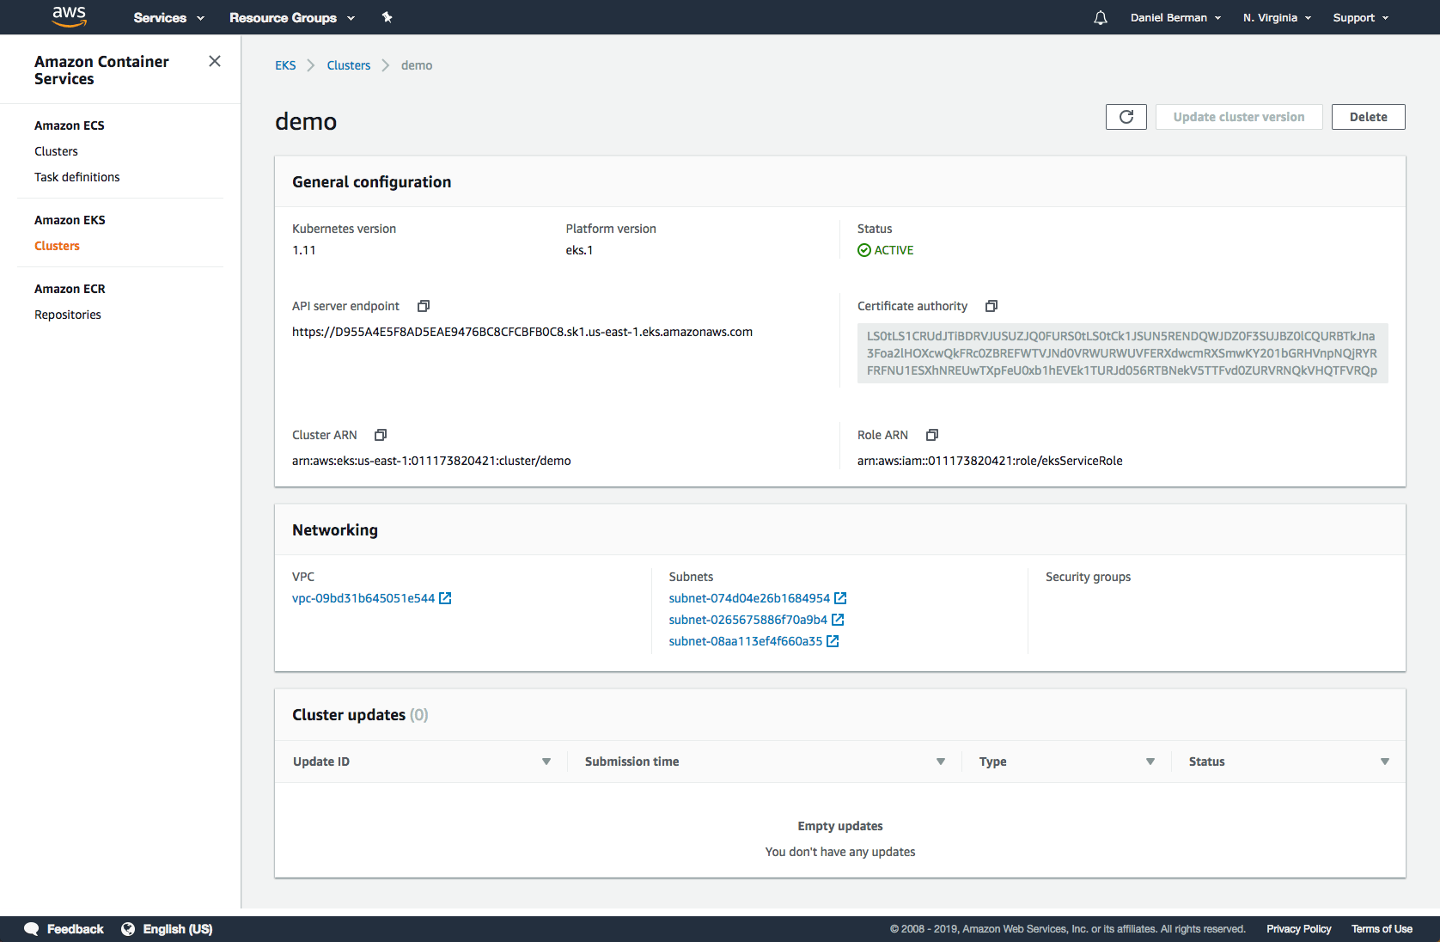](https://logz.io/wp-content/uploads/2019/02/general-configuration.png)

Step 4: Launching Kubernetes worker nodes

Now that we’ve set up our cluster and VPC networking, we can now launch Kubernetes worker nodes. To do this, we will again use a CloudFormation template.

Open CloudFormation, click **Create Stack**, and this time use the following template URL:

https://amazon-eks.s3-us-west-2.amazonaws.com/cloudformation/2019-01-

09/amazon-eks-nodegroup.yaml

Copy

[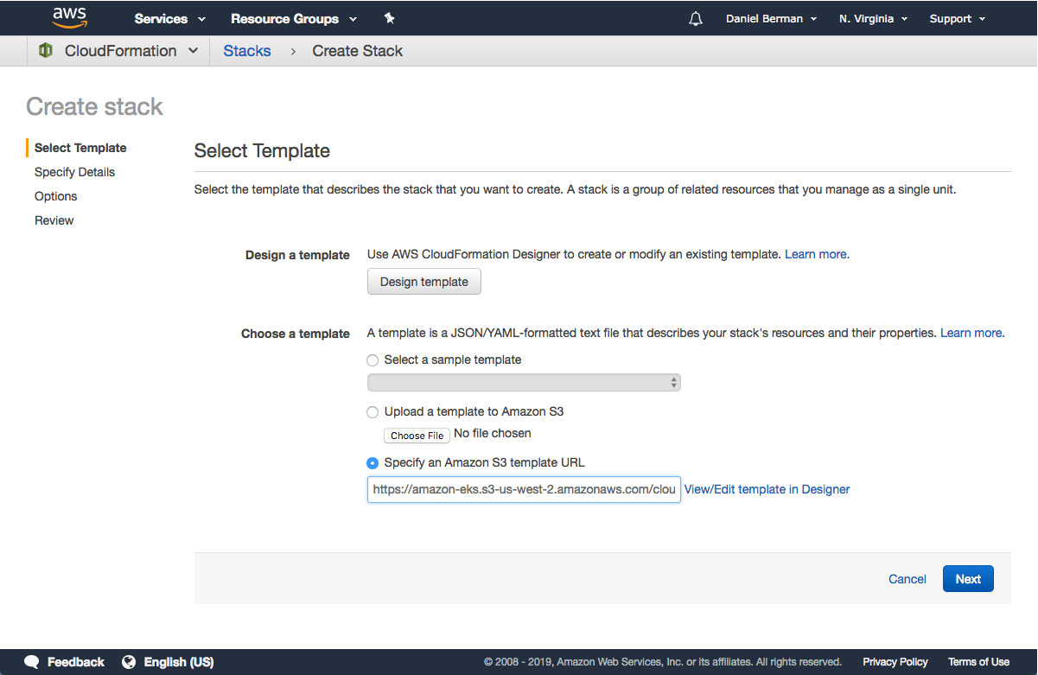](https://logz.io/wp-content/uploads/2019/02/select-template.png)

Clicking **Next**, name your stack, and in the EKS Cluster section enter the following details:

* **ClusterName** – the name of your Kubernetes cluster (e.g. demo)
* **ClusterControlPlaneSecurityGroup** – the same security group you used for creating the cluster in previous step.
* **NodeGroupName** – a name for your node group.
* **NodeAutoScalingGroupMinSize** – leave as-is. The minimum number of nodes that your worker node Auto Scaling group can scale to.
* **NodeAutoScalingGroupDesiredCapacity** – leave as-is. The desired number of nodes to scale to when your stack is created.
* **NodeAutoScalingGroupMaxSize** – leave as-is. The maximum number of nodes that your worker node Auto Scaling group can scale out to.
* **NodeInstanceType** – leave as-is. The instance type used for the worker nodes.
* **NodeImageId** – the Amazon EKS worker node AMI ID for the region you’re using. For us-east-1, for example: ami-0c5b63ec54dd3fc38
* **KeyName** – the name of an Amazon EC2 SSH key pair for connecting with the worker nodes once they launch.
* **BootstrapArguments** – leave empty. This field can be used to pass optional arguments to the worker nodes bootstrap script.
* **VpcId** – enter the ID of the VPC you created in Step 2 above.
* **Subnets** – select the three subnets you created in Step 2 above.

[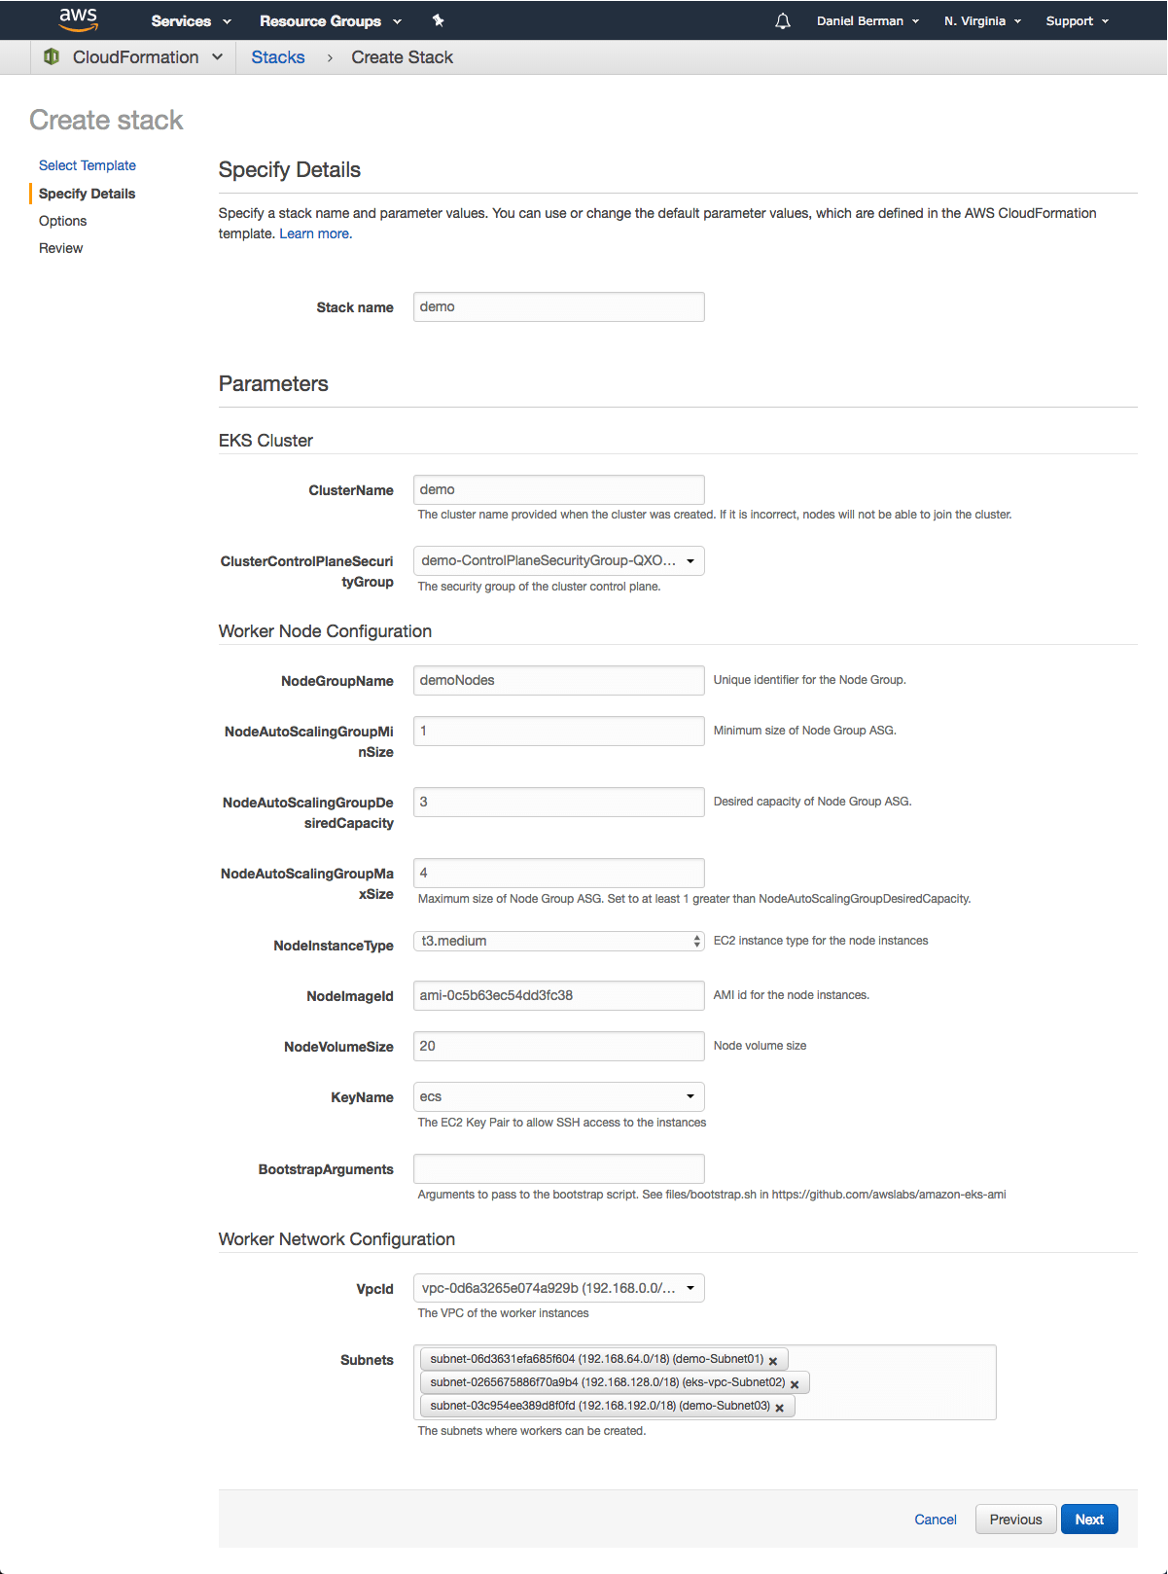](https://logz.io/wp-content/uploads/2019/02/stack-details.png)

Proceed to the Review page, select the check-box at the bottom of the page acknowledging that the stack might create IAM resources, and click **Create**.

CloudFormation creates the worker nodes with the VPC settings we entered — three new EC2 instances are created using the

As before, once the stack is created, open Outputs tab:

[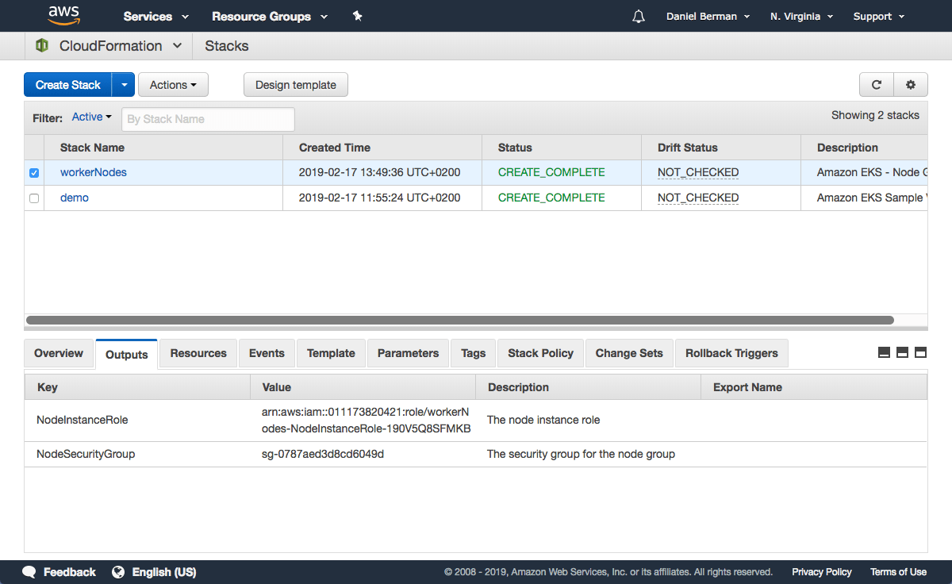](https://logz.io/wp-content/uploads/2019/02/open-outputs.png)

Note the value for *NodeInstanceRole*as you will need it for the next step — allowing the worker nodes to join our Kubernetes cluster.

To do this, first download the AWS authenticator configuration map:

curl -O

https://amazon-eks.s3-us-west-2.amazonaws.com/cloudformation/2019-01-09

/aws-auth-cm.yaml

Copy

Open the file and replace the rolearn with the ARN of the *NodeInstanceRole* created above:

apiVersion: v1

kind: ConfigMap

metadata:

name: aws-auth

namespace: kube-system

data:

mapRoles: |

- rolearn: <ARN of instance role>

username: system:node:{{EC2PrivateDNSName}}

groups:

- system:bootstrappers

- system:nodes

Copy

Save the file and apply the configuration:

kubectl apply -f aws-auth-cm.yaml

Copy

You should see the following output:

configmap/aws-auth created

Copy

Use kubectl to check on the status of your worker nodes:

kubectl get nodes --watch

NAME STATUS ROLES AGE VERSION

ip-192-168-245-194.ec2.internal Ready <none> <invalid> v1.11.5

ip-192-168-99-231.ec2.internal Ready <none> <invalid> v1.11.5

ip-192-168-140-20.ec2.internal Ready <none> <invalid> v1.11.5

Copy

Step 5: Installing a demo app on Kubernetes

Congrats! Your Kubernetes cluster is created and set up. To take her for a spin, we’re going to deploy a simple Guestbook app written in PHP and using Redis for storing guest entries.

The following commands create the different Kubernetes building blocks required to run the app — the Redis master replication controller, the Redis master service, the Redis slave replication controller, the Redis slave service, the Guestbook replication controller and the guestbook service itself:

kubectl apply -f https://raw.githubusercontent.com/kubernetes/examples/master/guestbook-go/redis-master-controller.json

kubectl apply -f https://raw.githubusercontent.com/kubernetes/examples/master/guestbook-go/redis-master-service.json

kubectl apply -f https://raw.githubusercontent.com/kubernetes/examples/master/guestbook-go/redis-slave-controller.json

kubectl apply -f https://raw.githubusercontent.com/kubernetes/examples/master/guestbook-go/redis-slave-service.json

kubectl apply -f https://raw.githubusercontent.com/kubernetes/examples/master/guestbook-go/guestbook-controller.json

kubectl apply -f https://raw.githubusercontent.com/kubernetes/examples/master/guestbook-go/guestbook-service.json

Copy

Use kubectl to see a list of your services:

kubectl get svc

guestbook LoadBalancer 10.100.17.29 aeeb4ae3132ac11e99a8d12b26742fff-1272962453.us-east-1.elb.amazonaws.com 3000:31747/TCP 7m

kubernetes ClusterIP 10.100.0.1 <none> 443/TCP 1h

redis-master ClusterIP 10.100.224.82 <none> 6379/TCP 8m

redis-slave ClusterIP 10.100.150.193 <none> 6379/TCP 8m

Copy

Open your browser and point to the guestbook’s external IP at port 3000:[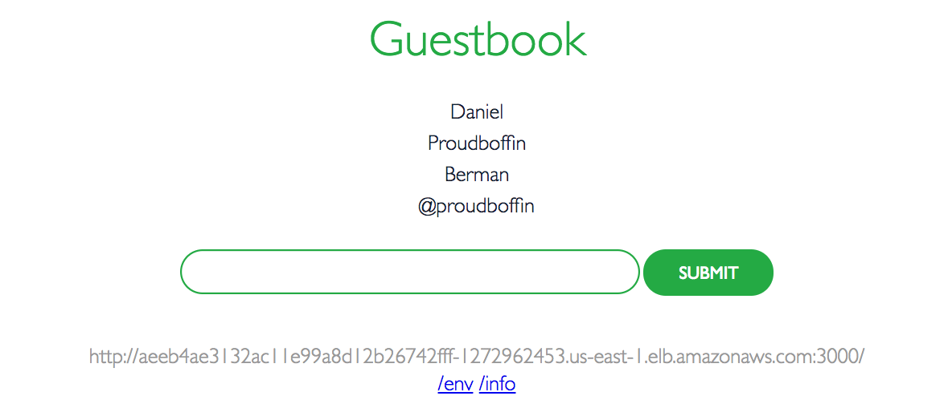](https://logz.io/wp-content/uploads/2019/02/guestbook-1.png)